**1.Introduction:**

**TECHPRO has over 16 years of experience in providing technology solutions and products in three areas: (1) Techpro security and building system (SBS); (2) digital printing and data processing (DAP); (3) Construction and maintenance services.**

**1.1Overview:**

The consulting services offered by our company help to plan and implement a whole cycle of changes of the company information system. They are aimed to detect and work out recommendations and help to solve customers’ business tasks based on knowledge, skills and competence in the fields of management and IT.

**1.2**.**Purpose:**

We are committed to achieve Customer’s Business Objectives by Delivering Professional Services & adopting Innovative Technologies. Our Mission: To channelize the Knowledge, Expertise and Experience that has gained over the years from recommending IT products and Effective solutions for our Customers.

2. **Problem definition and Design thinking:**

**2.1: Empathy map:**

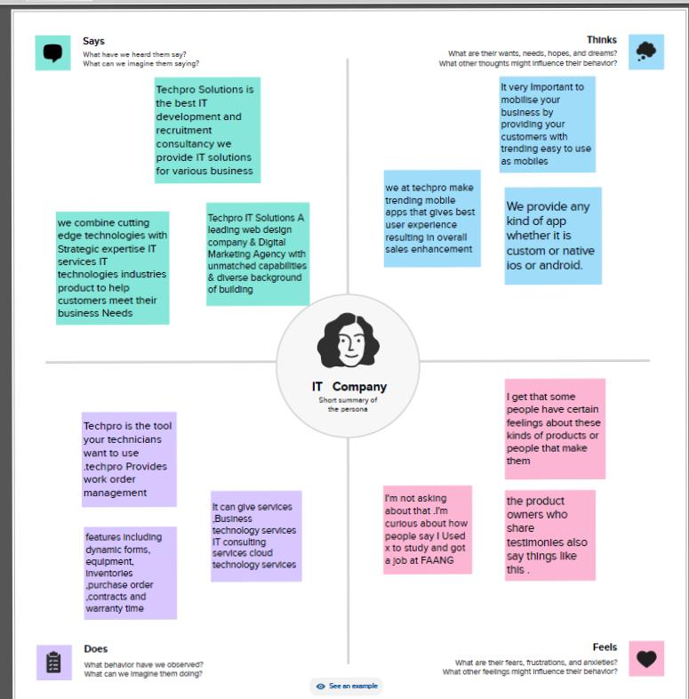

**2.2: Ideation and Brainstorm map:**

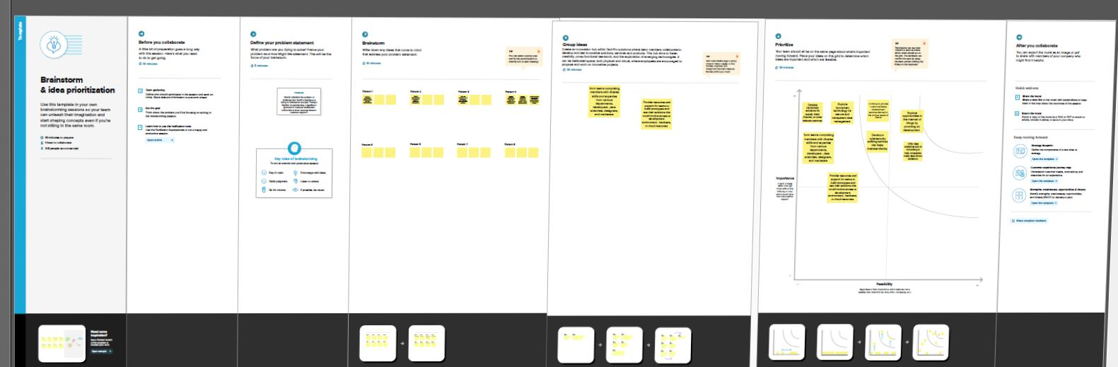

**3.Advantages and Disadvantages**:

We strive to be a trusted partner as an IT Solution provider. We are committed to achieve Customer’s Business Objectives by Delivering Professional Services & adopting Innovative Technologies.

To channelize the Knowledge, Expertise and Experience that has gained over the years from recommending IT products and Effective solutions for our Customers. Deep industry knowledge and exceptional technical expertise combined with best business ethics makes TechPro the global leader in IT Services and Management Consulting.

4.**Source Code** :https://github.com/santhiyasasikumar/TechPro

5.**Conclusion** :

The program had been successfully executed